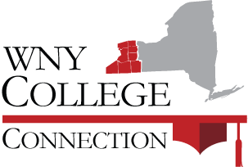

Consortium Admissions Directors

Chris Dearth SUNY Fredonia Dearth@fredonia.edu
Cory Unis Alfred University unis@alfred.edu
Cris McDermott Niagara University cmm@niagara.edu
David Luzer Medaille College dluzer@medaille.edu
Deborah Goodrich Alfred State, SUNY College of Tech. goodridj@alfredstate.edu
Dr. Carmela Thompson Buffalo State College thompsc@buffalostate.edu
Frank Williams Daemen College fwilliam@daemen.edu
Kathleen Saunders Niagara County Community College Saunders@niagaracc.suny.edu
Kevin Ernst Bryant & Stratton College kernst@bryantstratton.edu
Laura Fitzgerald Villa Maria College fitzgeraldl@villa.edu
Maria Povlock Trocaire College povlockm@trocaire.edu
Matthew Reitnour Houghton College Matthew.Reitnour@houghton.edu
Molly Strassem Canisius College strassem@canisius.edu
Monica Emery St. Bonaventure University memery@sbu.edu
Patricia Armstrong University at Buffalo PGA2@buffalo.edu
Erik D’Aquino Erie Community College daquino@ecc.edu
Steve Ethridge Bryant & Stratton sbethridge@bryantstratton.edu
Steven Smith D’Youville College smith@dyc.edu
Lindsay Gerhardt Genesee Community College lagerhardt@genesee.edu
Tim Lee Hilbert College tlee@hilbert.edu
Tina Massa Empire State College tina.massa@esc.edu
Wendy Present Jamestown Community College WendyPresent@mail.sunyjcc.edu

